Case Study of the
Business Environment Network (BEN) – Nigeria

by

Dr Luca Crudeli and Adenike Kazalma-Mantey

Presented at the Public-Private Dialogue 2010 Workshop
(Vienna, June 1-3 2010)

Context & particulars of the partnership

A new initiative
The Business Environment Network (BEN) is a fairly new Public Private Dialogue platform which was created by the House of Representatives of the Nigerian National Assembly. The platform will bring together members of the legislative, executive (and their regulatory bodies) and private sector stakeholders to address key issues related to the business environment to enhance competition and economic growth. It will also offer improved mechanisms for effective policy and regulatory analysis improved policy making knowledge and establish accessible channels to members in the private sector. The network if successful will be the first of its kind being constituted by the legislative arm of government to bring together the executive and private sector in the spirit of dialogue that focuses solely on issues affect ting the business environment.

The key objectives of the platform include:
- Strengthening coordination between the executive, legislature and private sector with the aim of mainstreaming business environment issues and policies in national development programs.
- Play a proactive role in ensuring the effective implementation of enhanced business environment policy issues in Nigeria through the active participation of parliamentarians and their constituents in business environment dialogue;
- Increased information-sharing on current business environment related issues a view to improving the design and analysis of new/existing policies or regulations.
- Engender increased participation of private sector actors in the policy/legislative formulation and reform processes.
- Improved monitoring and evaluation of policies and regulations related to improving the business climate in Nigeria;
- Document lessons learned and good practices in business environment policy related issues in Nigeria.

The project is being supported by ENABLE which is a DFID funded program. The ENABLE program adopts an M4P approach and supports the proponents to own the project by providing the necessary technical capacity.

Status of the Partnership

The BEN is still at the very elementary formation stages. So far the donor support received has been technical assistant to devise a framework upon which the platform will be developed. Key areas which were discussed and highlighted was structure, guiding principles, key purpose and objectives, budgeting requirements and secretariat functions etc.

The emergent structure of the BEN is as follows:

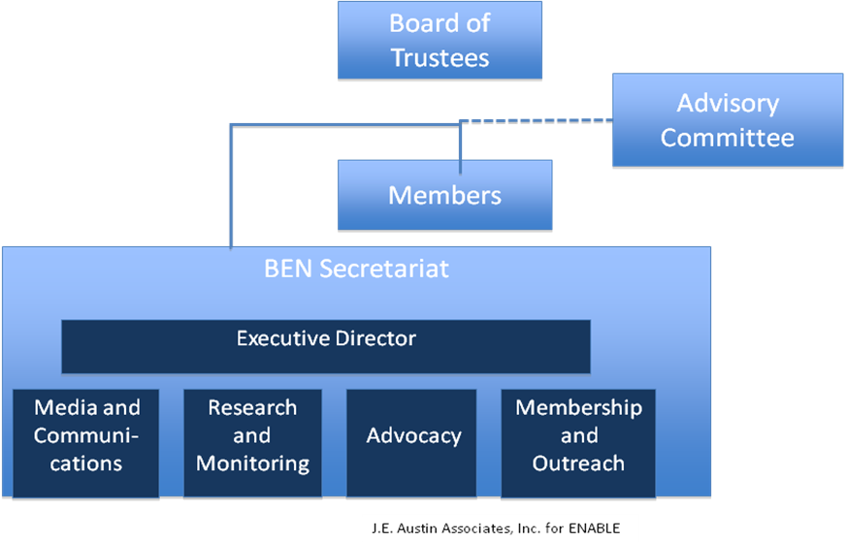

The structure of the platform is comprised of four main components:
- The Board of Trustees: Consists of the founders of the platforms which are the 7 legislative members of the lower house of the National Assembly. Members of the Board of Trustees will be selected based on the relevant committees which they sit on at the National Assembly.
- The Advisory Committee: This consists of both the Business Members Organisations and Selected Regulatory Organisations and key individuals in both private sector and government.
- Members: The BEN is to recruit more members from the lower house who sit on relevant business committees to be part of the BEN.
- BEN Secretariat: The secretariat will consist of an Executive Director, who would be responsible for the day-to-day operations of the secretariat. He will be assisted by a Media & Communications Officer, Research & Monitoring Officer, Advocacy Officer and a Membership & Outreach Manager.

Planned Structure & Processes
- A Functional Secretariat: The secretariat will facilitate interactions between the advisory committee, the members and the private sector to ensure a broad representation of interests, adequate research in support of issues raised and that activities of the platform are well-coordinated. The secretariat will also play an active role in the monitoring and implementation of reforms.
- Business Environment Roundtables: The BEN will use the Business Environment Roundtable to engage the private sector in dialogue to set agendas for reform, provide access for private sector to also submit positions papers. The roundtables will be convened on the onset based on a demand basis and post events will produce publications on the discussions, outcomes and follow-up activities.
- Internal Group Meetings: The BEN will hold internal group meeting to determine specific issue to focus for discussion. It will employ specific filters for decision-making such as listening to the Secretariat, Advisory Committee, National Assembly proceedings, roundtables etc. It will prioritise issues based on potential impact on Nigerian businesses in particular small and medium scale enterprises.

Results

As it is still a very new project, the platform he BEN is yet to record any results.

Challenges & Way Forward

Challenge -Sustainable funding for the Platform
The Enable program adopts the M4P approach. Thus does not directly fund activities of its clients but supports partners to relying on their own systems in identifying solutions to problems. The proponents will have to source for funding initially for the secretariat’s operational & start-up costs in the short-term. In the long term it will look to institutionalizing the platform into the National Assembly having built sufficient credibility.

Development of a Strategic Plan & Establishment of the Advisory Board
The platform will require the development of a strategic plan that will guide governance, procedures, account management systems to ensure transparency and accountability.

Building the capacity of staff of the Secretariat
The secretariat staff will need to be trained in basic advocacy skills, communications and media relations, research to provide other technical and administrative support to the platform.

Official Launch of the Platform & Building Linkages with external resources
The proponents will have to officially launch the platform to give it the desired publicity and generate awareness of its existence and the objectives it wishes to accomplish. In order to remain lean, the platforms will also need to establish link with other institutions such as sectoral business experts, research organizations, think/tanks, universities, policy institutes etc.

Details of the Authors

Dr Luca Crudeli is the Programme Manager for the DFID – ENABLE program and has extensive experience in private sector development in Africa and Europe.

Adenike Kazalma-Mantey joined DFID’s ENABLE program in May 2009 as the Government Portfolio Manager. Prior to working with ENABLE, Adenike has worked with various public agencies in Nigeria for 5 years as a senior program officer on a number of national projects including the development of a National Information Technology Policy & Cybersecurity Policy and was principally involved in creating the platforms for dialogue among industry stakeholders. She also worked for 3 years in the private sector and maintains a good understanding of both systems. She holds a B.Sc Degree in Accounting and holds Masters in Business Administration (MBA) from Cardiff University, UK.

